Resisting and Reproducing Neoliberal Capitalism:
A Case Study of Muslimah Labourers in Central Java, Indonesia

Inaya Rakhmani

Asia Research Centre, Universitas Indonesia and the Department of Communication, Faculty of Social and Political Sciences, Universitas Indonesia

Email: inaya.r@ui.ac.id

Diatyka Widya Permata Yasih

Asia Research Centre, Universitas Indonesia and the Department of Sociology, Faculty of Social and Political Sciences, Universitas Indonesia

Email: diatyka.widya09@ui.ac.id

In the context of Muslim-majority Indonesia, we see the strengthening of Islamic piety as a response towards the reorganisations of people’s daily life under neoliberal imperatives, which have led to the proliferation of precarious employment practices while promoting marketisation of basic social services. We draw a link between the escalation of Islamic expression among the often overlooked Muslimah labourers in the historical locality of Solo, Central Java, Indonesia and their articulation of grievances. We find that Muslimah labourers in Solo compartmentalise their public and domestic space to fulfil distinctive gendered-roles. They use organised labour movements to fight for workers’ rights and realise the imagination of working-class solidarity—all the while donning hijabs and negotiating curfews from their male guardians. At the same time, they play caregiving roles to parents, children and husbands; filling the absence of basic social and health services they demand from the state, while ensuring security in the afterlife not achievable in their material one. The pious common sense impinges on the collective wills of the workers to challenge the neoliberal structures that shape
their (and our) experiences with marginalisation. But it is no less meaningful in maintaining
life (and being resilient) in an increasingly unfair socio-economic world.

Key word: Indonesia, neoliberal capitalism, precarity, Islam, common sense, Muslimah labourers, everyday resistance

Resisting and Reproducing Neoliberal Capitalism:
A Case Study of Muslimah Labourers in Central Java, Indonesia

Inaya Rakhmani and Diatyka Widya Permata Yasih

Introduction

On 11 December 2021, Erick Thohir, Minister of State Owned Enterprises, was awarded the Sharia Economic Driver by the Indonesian Ulema Council (Majlis Ulama Indonesia—MUI) for his commitment and consistency in mobilising various national economic resources for the benefit of the country’s ummah (Damayanti, 2021). This award was given in relation to his position as chair of the Sharia Economic Community (Masyarakat Ekonomi Syariah—MES). Thohir was elected based on a congress decision led by current Indonesian Vice President and former MUI president Ma’ruf Amin, replacing Wimboh Santoso, former chair of the Financial Service Authority (Otoritas Jasa Keuangan—OJK), who held the post from 2017 to 2022.

Around the same time, Amin announced that the development of digital technologies must be used to accelerate the growth of Indonesia’s sharia economics. According to Amin, this should be done via market inflow and the strengthening of sharia financial institutions and businesses (Yasmin, 2021). Amin urged the Indonesian Sharia Supervisory Board (Dewan Pengawas Syariah—DPS), organised under MUI, to develop the necessary infrastructure to expand Indonesia’s Islamic financial ecosystem.

In early 2022, Thohir’s Deputy Minister, Pahala Nugraha Mansury, stated that Indonesia’s potential for the export of halal products reached US$ 3.6 billion, while the value of halal products and services could reach US$ 5.1 billion (Cakti & Kurmala, 2022). “So, the market is huge; it is just a matter of how we can use it together. Trade will become one of the key components of the total expenditure of the Muslim community, including halal food products, fashion, pharmaceuticals, and cosmetics,” Mansury stated (Cakti & Kurmala, 2022). Likewise, a range of activities organised by the Sharia Young Entrepreneur Seminar regularly encourages the production and consumption of halal products, together with the export of Indonesian halal products to Muslim majority countries, specifically those part of the Organization of Islamic Cooperation (OIC), such as Morocco, Sudan, and Saudi Arabia. Thohir also plans to link MES’ network to the Indonesian diaspora in Pakistan, the United Arab Emirates, and Brunei (Cakti & Kurmala, 2022) as part of this agenda.

These initiatives might seem to validate concerns regarding the Islamisation of Indonesia. Such argues that there is growing political assertiveness from various proponents of Islamism to advocate for economic and social justice for Muslims at the expense of religious minority groups (Hasyim, 2019). However, we understand this as a social response from Indonesian Muslims toward an increasingly globalised economy (Hadiz, 2016), more precisely neoliberal capitalism (Harvey, 2005).

Since roughly the 1980s, neoliberal reorganisation has affected almost every country worldwide. While definitions diverge, scholars generally agree that it involves a gradual withdrawal of the state from delivering basic health and social services to every citizen (see Harvey, 2005). For countries of the developing world, like Indonesia, state deregulation has permitted Foreign Direct Investments to finance the kinds of goods and services provided by the private sector. Likewise, the private sector has taken greater control over providing everyday sustenance (water, food, electricity, housing) and ways to ensure the quality of life (health, education, leisure). This has allowed for more employment opportunities. At the same time, access to stable, decent and secure jobs is depleting.

Importantly, neoliberal restructuring promised greater prosperity as the middle classes expanded and benefited from stable economic growth. Indonesia has seen decades of steady economic growth (short of the COVID-19 pandemic), but its inequalities are at their highest in history (Oxfam, 2017; Hill, 2021). In other words, the stable economic growth that Indonesia has seen in the past decades—which has expanded the middle classes by roughly twofold—has generally benefited the upper rather than working classes.

We place the Muslim middle and working classes within this overall development. Such has also emerged in Malaysia, Turkey, Egypt, India, and Indonesia (Sandikci & Rice, 2011). Likewise, we also position the sharia economy envisioned by Muslim bureaucrats and activists in Indonesia within neoliberal capitalism, where the growing Muslim middle and rising aspirations of working classes have resulted in a connection between Islamic values with market practices (Rakhmani, 2016). Such a link, we see, is a consequence of “neoliberal economic restructuring programs” (Sandikci & Rice, 2011: 250), where middle and working-class Muslims must navigate an increasingly volatile and insecure social world. This is the background for the circulation of halal goods and services for Muslim markets.

Thus, for us, the issue at hand is less about Islamising the neoliberal social world Muslims live in; but how to earn and consume within a capitalist system without transgressing Islamic boundaries. Islamic laws such as riba’, or usury, have arguably posed the most significant challenge in negotiating Islamism and capitalism (Mahdi, 2014). On the one hand, to survive and live within a neoliberal capitalist system, Muslims must compete within market systems and work within profit-maximising labour processes. On the other hand, they are demanded by Islamic authorities and fellow Muslims to apply redistribution via zakat and sadaqat for want of a better afterlife. There is a discursive tension between socio-economic Islamic morality and neoliberal ideology (see Gramsci, 1976). But while wealth and social inequalities are understood as failures of neoliberal capitalism, these are addressed through technical solutions via legal instruments, government regulation, and professionalism (Wills, 2014).

We argue that the kind of sharia economy advocated by Indonesian statesmen and Muslim politicians is less an alternative Islamic economic system that benefits the ummah than it is about reducing and managing this discursive tension between Islamism and capitalism. We agree with Madi (2014), who takes the Turkish case and argues that this tension is regulated by introducing Islamic morality into capitalism and redefining Islam and capitalism (145). Such a practice, as has emerged in Turkey, deepened modernity and capitalism by using economic rationality to widen the space (see Bourdieu, 1977) for Islamic values within the workings of neoliberal capitalism.

But within this body of work, so much more has been written on the Muslim middle class (Nasr, 2009; Mujani et al., 2012; Sandikci & Rice, 2011; Rakhmani, 2016), and so few are being written about the consumption practices of the Muslim working class. And, even less attention is being given to Muslim women, which, whether directly or indirectly, reinforces the kinds of patriarchic ideologies criticised by scholars working on Islam by leaving the stories of women largely understudied in the body of literature (Mahmoud, 2011). That is why the purpose of this paper is to reveal the everyday realities of working Muslim women in resolving their discursive tension between Islamic and neoliberal ideologies. While we mainstream the feminist voice in this overwhelmingly, at best, gender-blind and, at worst, patriarchal literature (Rahman, 1996), we maintain our connection to broader debates regarding the critique of neoliberalism.

The sakinah family as common sense

In order to achieve the reflexive purpose of this article, we borrow Gramsci’s notion of common sense, which places emphasis on subjectivity, confrontation with external reality, but also stresses on contradictions, fluidity and opportunities for change. Common sense (Gramsci, 1971) refers to an amalgamation of shared beliefs, which are accepted unquestioningly among broad sections of society. But, it is in fact reliant on the configurations of social relationships of power throughout history.

Common sense provides easily-available knowledge to those who experience socio-economic marginalisation in ways that allow them to understand their place in the world (Crehan, 2016). Formed within struggles over capitalist hegemony, common sense includes heterogenous conceptions of the cultural world. Likewise, it is ‘fragmentary, incoherent and [at times] inconsequential’ (Gramsci, 1971: 419; emphasis added). The fragmentation and heterogeneity of common sense pose a challenge to the shaping of collective wills to challenge a status quo (Filippini, 2017: 110-111) that impinges on the emancipation of labourers.

In neoliberal Indonesia, we witness expectations for women to prioritise family over paid work responsibilities (Sakai and Fauzia, 2016), despite increased demands for middle and lower-middle class households to survive with double incomes (Utomo, 2012; Naafs, 2012). This has been traced back to the New Order’s “state ibuism”, or the propagation of women’s obedience to husbands and the state to support nationwide modernisation programmes and economic growth (Suryakusuma, 2011). Like so many gendered practices that are turned into norms under the New Order’s state modernisation projects (Sen, 2002), the element of double burden (peran ganda) or the notion of women’s dual function in public and domestic space, persists to today. Women are encouraged to participate in state organisations and/or in the workplace, on top of their supposedly primary responsibilities as wife, mother, and carer of the household.

While the authoritarian rule has ended, and massive decentralisation programmes have been put in place with hopes that it would strengthen the democratic agenda, the element of women’s dual function has not dissipated; rather, they have mutated with rising Islamic expressions. State population control since the 2000s is framed in national campaigns as achieving the sakinah family (happy Moslem family), rooted in the 1980s and 1990s’ “gender harmony” along the lines of state ibuism (Wierenga, 2018). Women are expected to not only be obedient to authoritative male figures, but also do so piously. We think that such ideas have socially reinforced the notion that women’s domestic responsibilities are their natural roles in society (Sakai and Fauzia, 2016).

We link the idea of the sakinah family with the Gramscian notion of common sense. By observing daily practices, we were able to unpack how everyday politics and micro resistance (see Ford and Piper, 2007) against capitalist hegemony simultaneously benefits its sustaining. In light of that, in a contradictory and incoherent but no less meaningful way, this pious common sense helps Muslimah labourers live with socio-economic marginality; and it is also useful for them to organise daily responses to it. But to us, such a subjective understanding is very much connected to the external economic realities of neoliberal restructuring. After all, individualisation is increasingly becoming the norm; which normalises competition, casualisation, and the overall attitude towards job insecurity. Gradually, labourers and their families, instead of the state and businesses, are rendered responsible for the improvement of their own wellbeing (Wakefield and Flemming, 2019). And here, we see the function of Islamic values in managing social insecurities.

We chose Solo Raya as a specific locality that portrays contradictions within the post-authoritarian period. The region, academically overshadowed by Jakarta, has been the centre of activities of Islamist organisations categorised as “radical” (Hadiz 2010, 2011), which have paradoxically provided broader sections of the working class with Islamic ideas that shape their understanding of their socio-economic marginality. For us, the site of Solo Raya provides a specific meeting point between Islamic and working class movements, that occured within a moment in history where attempts to tame the discursive tensions between Islamism and capitalism are ever so clearly carried out in public and domestic spaces (Rakhmani, 2019).

Against such a historical background, we purposely selected major labour organisations and studied their contexts (see La Botz, 2001). It was during the process of studying that we noticed the ways Islamic rituals and gatherings are increasingly practiced in union activities.The religious activities facilitate labour consolidations, and, at times, moderate collective movements with narratives of the afterlife. It was also made known to us how masculine these movements are (see Ford and Parker, 2008), which made us curious about the role of women in these processes in micro-political settings. Thus, we selected a small group of nine research participants who permitted us into their daily lives and solidarity movements. We employed snowball sampling, relying on the role of a gatekeeper to help identify and recruit Muslimah labourers.

The research participants, ranging from 19 to 41 years old, are employees and/or former employees of a textile factory in Solo Raya. Most of them are hired under temporary employment contracts. Some of them supplement their income by running their own household business. Every Muslimah labourer we talked to are responsible for the wellbeing of another family member. Those who are married are responsible for the care of their children and sometimes parents. Those who are single are often involved in the care of their parents and younger siblings.

Thus, our socio-historical understandings, as well as our lived experiences within the Javanese, Islamic milieu, guided the way we interpreted primary data. We were inspired by digital ethnography as planning praxis (Sandercock and Attili, 2010) to address the nature of data collection within the context of the COVID-19 pandemic. Specifically, the implementation of social distancing has also opened up new ways of using digital media for organising public and domestic spaces (Rakhmani, Utomo, Phillips, Setyonaluri, 2020). As such, we gathered data from a combination of photo-journaling/photo diary studies and unstructured interviews facilitated by messenger groups, hybrid online meetings (see Phillips and Plesner, 2013), which were carried out during the pandemic (November 2021 to March 2022).

In the photo-diary study, the Muslimah labourers were asked to report on the events of their daily lives, especially those related to paid work, household chores and caring responsibilities, as well as recreational activities. We focus on the kinds of Islamic practices that involve the circulation of halal goods and services in their social networks. Thus, we delve into the effects of such Islamic practices in diverting the expression of the labourers' grievances away from class-based uprising. It is with this in mind that we unpack how the sakinah family helps them make sense of their aggravations and responses to the failures of neoliberal work.

Muslimah labourers’ material grievances and their religious solutions

In these specific historical conditions and discursive tensions between Islamism and capitalism (Madi, 2014), we approach the everyday experience of Muslimah labourers as a way to regulate the introduction of Islamic morality into hegemonic capitalist structures. As such, we zoom into the notion of the sakinah family as common sense–which is fragmented, incoherent, and, at times, inconsequential. The double workload of family care and paid work that inflicts on Muslimah labourers, to us, is a kind of micro-politics (power struggle in everyday social settings) indicative of this discursive tension.

We thus dissect social and personal meanings of Islamism as expressed by Muslimah labourers. We do this by appreciating their roles as the bearers of responsibilities of unpaid work. Unpaid work lessens the cost of care, supports household economies, and often fills in for the lack of basic health and social services. We found increasing precarity-in-work and in life (Parfitt and Barnes, 2020) as a major grievance among Muslimah labourers. In Indonesia, neoliberal restructuring has promoted policies that make the labour market more flexible. Such policies have contributed to the gradual rise of precarious employment practices in the formal sector, which is conventionally associated with stable working conditions.

As previously mentioned, some Muslimah labourers in our study are hired under temporary employment contracts. As temporary workers, they receive limited social security or other work benefits (Primadytha, 2022). Specifically, the enactment of the Job Creation Law in 2020 has reduced the cost of terminating permanent staff for the companies (Syechbubakr, 2020); which in turn legitimises casualisation. Other Muslimah labourers in our study mention that they were recently dismissed from their employment, because of their involvement in collective organising to demand better workplace safety. There appears to be a link between precarious work and precarious lives, as stated by some Muslimah labourers:

“Whether a contractual worker is covered by BPJS [state-sponsored health care insurance] depends on the company. In 2012, I was still a contractual worker in X company which participated in BPJS… When I resigned we could liquidate [severance] at the BPJS office. In the company [I work in] now permanent employees are prioritised. Contractual workers whether acknowledged or not, I don’t know. THR [annual labour allowance] is also at the company's liking, not following duration of employment” (M, hybrid group interview, 19 December 2021).

“We were terminated unilaterally by the company, and I still have dependents; two parents; my father is 93 years old and my mother is 84 years old, and my father has had a heart condition for five years now” (L, hybrid group interview, 28 November 2021).

Labourers rely largely on themselves and their families to navigate everyday precarity. To mitigate the impact of the pandemic, for instance, the government has taken the initiative to provide wage subsidy assistance (BSU) for labourers (Tobing et al, 2022). A Muslimah labourer in our study mentions how BSU funds has helped her to meet the needs of daily life. However, BSU’s vulnerability to error and fraud means that there is a lack of predictability, consistency and transparency in its disbursement (A, photo diary studies, 12 December February 2021).

Picture 1. Liquidating social security insurance.
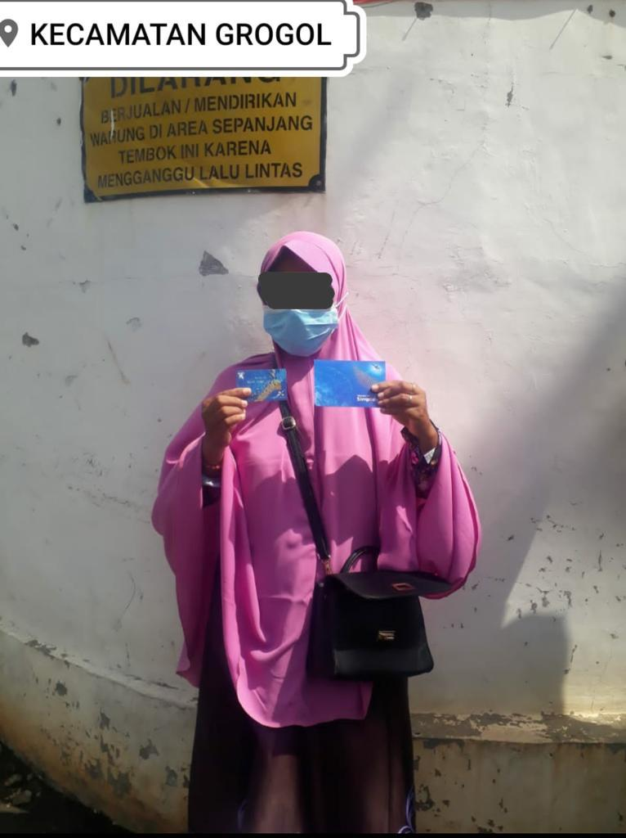
Source: A, photo diary studies, 2 December 2021.

A (picture 1) is holding up her bank account book and ATM card she made to liquidate her wage subsidy assistance from her social security insurance. “I am very happy during the pandemic I am not working because of termination I receive assistance. I can use it to pay debt instalments, even if I don’t know when it can be liquidated” (A, photo diary studies, 2 December 2021).

Picture 2. Participating in a labour demonstration about low minimum wage.

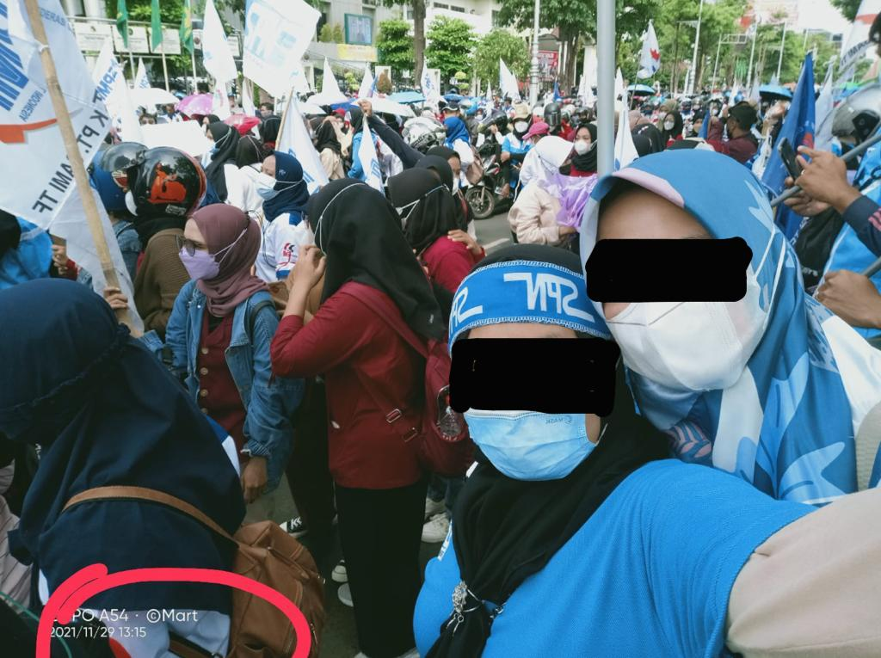
Source: M, photo diary studies, 29 November 2021.

The kinds of precarity that comes with casual work is felt collectively, and Muslimah labourers learn about the benefits of social safety nets through labour unions. But not all Muslimah labourers are involved in unionising, which is compounded as well by a general absence of effective unionism. Furthermore, the Muslimah labourers we talked to are very aware of the fact that labour demonstrations are much less effective than they desire it to be. Reflecting on a series of protests organised by unions against the implementation of the Job Creation Law, a Muslimah labourer comments that “even though there is no consequence, at least we express our opinions. Who knows, the government might change their minds. But it turns out not” (R, hybrid group interview, 19 December 2021).

The kinds of disappointment and frustration towards not being heard during demonstrations are followed and, for lack of a better term, distracted by their domestic roles. “Participated in the [labour] action with seniors… Went home and directly put the child to sleep… Directly made time time to some clothes” (M, photo diary study, 29 November 2021). Along with engagement in domestic chores, participation in religious activities, help to eliminate work-related stress, while also moderate workplace anger. A Muslimah labourer expresses how happy she was after being unemployed “more time to get closer to God … more time to take care of the kids (A, hybrid group interview, 28 November 2021).

Moreover, Islamic rituals help organise time and space that assist them to divide time and space between their domestic and public lives. “I hear the Subuh calling of prayers, woke up, and plugged the rice cooker and washed dishes … Woke up husband and asked him to take the child to school because [I] have a morning shift” (M, photo diary study, 30 November 2021). Having Islamic rituals to cue in on how to organise domestic and public responsibilities under neoliberal settings is felt more largely. Going to a local mosque at the end of the day, after they have finished their paid and unpaid work, is a daily relief they take solace in (picture 3).

Picture 3. Self-soothing at a local mosque.

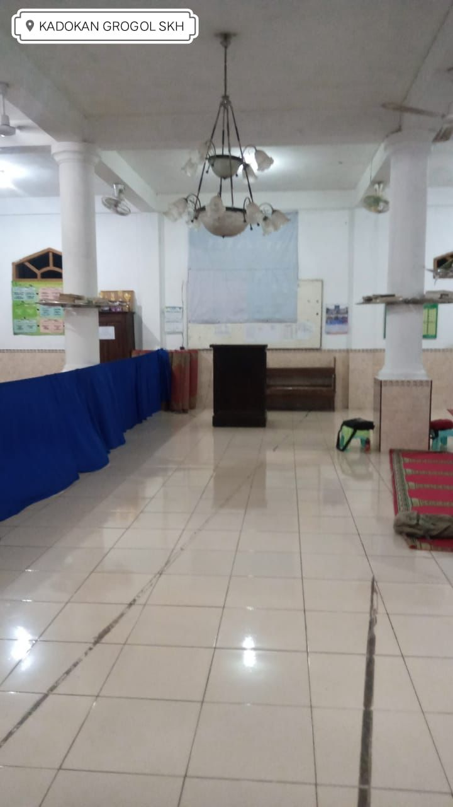
Source: F, photo diary studies, 29 November 2021.

Picture 3 is a personal view shared by F, who “after taking care of, teaching my younger sibling and cleaning my house I went to the mosque closest to home to participate in a routine Quranic recitation [pengajian] for young Muslims” (F, photo diary studies, 29 November 2021). Quranic recitations are social events that not only help organise their days, but also provide a space to self-regulate responses towards social frustrations. “[participating in Quranic recitations] I have done since I was a child. Father and mother taught me … I gained knowledge. Like guidance. For everyday life. Consciousness, to always be grateful” (V, hybrid group discussion, 28 November 2021).

These Islamic gatherings are also a space for socialisation, some of them through the initiatives of village and neighbourhood based Family Welfare Guidance (Pembinaan Kesejahteraan Keluarga–PKK). The PKK is widely considered as a government-run women organisation that played a key role in the bureaucratic state’s efforts to exercise control over society (Brenner, 1999). Muslimah labourers participate in PKK activities, and also organise arisan (rotating fund practice).

Arisan is a financing and social activity for women, predominantly in peri-urban and rural communities (Haryani and Dombroski, 2022); and serves as a reason to meet regularly during which members put in the equal amount of money. Each meeting, the winner takes home the whole pot based on kocokan (draw); but at times, those needing the funds the most are prioritised. The PKK and arisan are both organised in the mosque yard, together with leisure activities (eating together). Importantly, their belief in the rule of law (demanding social security and minimum wage from the state), saving money and future planning , as well as leisure activities, indicate them practicing middle class values. This is done so despite it contrasting sharply with their experience with labour precarity.

Picture 4. Out for chicken steak.

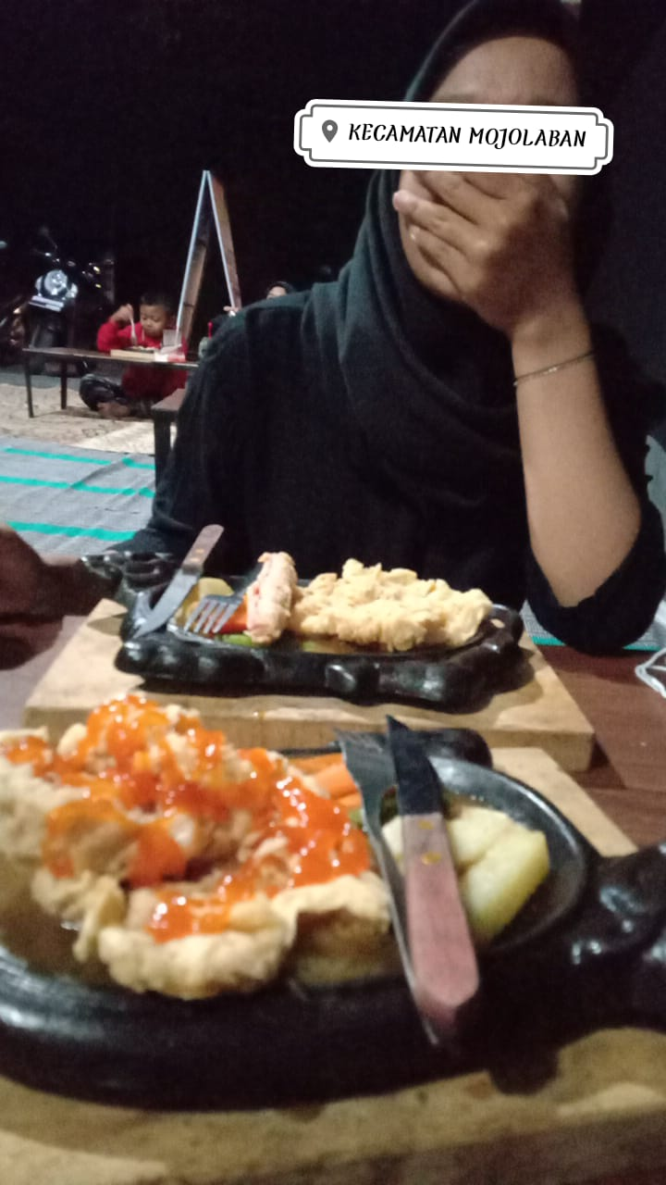
Source: D, photo diary study, 29 November 2021.

Picture 4 shows D, having spent all day taking care of her younger sibling, enjoying her favourite meal (chicken steak) since she is free of her evening prayers due to menstruation; to which she expressed alhamdulillah (thank God). At other times enjoying dinner while watching Korean drama on their smartphone over the Chinese streaming platform WeTV (D, photo diary study, 30 November 2022). While working and living precariously, Muslimah labourers aspire to live a middle class life, sustained by the imagined lifestyles associated with the consuming class. This is characterised by increased consumption, improved household wellbeing and access to higher-quality services and leisure time (Simone and Fauzan, 2013).

Among Muslimah labourers, we identify practices of purchasing goods and services in ways that are approved by the Islamic principles, while at the same time address the labourers desire to live a middle class life. This particular mode of consumption contributes in reconciling the disjuncture between the ideas of a better life promised by neoliberalism and the lived-realities of living precariously (Cravets and Sandikci, 2014). This disjuncture is responded with a negotiation between Islamic and traditional principles, through consumption practices.

Picture 5. Buying jamu.

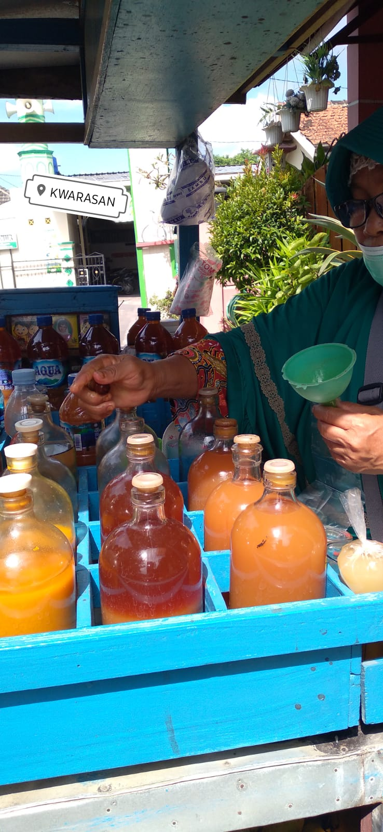
Source: H, photo diary studies, 30 November 2021.

Such a mode of consumption is demonstrated, among others, by the Muslimah labourers' reliance on traditional remedies, such as jamu (an Indonesian traditional medicine, composed mainly from roots of plants) for their healthcare needs (Krier, 2011). They also make Greco-Arab and Islamic herbal medicine, such as honey and black seeds, the first choice of treatment for an array of ailments. Traditional remedies, compared to modern medicines, are considered to be less invasive and less aggressive (Krier, 2011). They also support Indonesian-Islamic belief and medical systems

While they source jamu from street vendors, jamu is one of the key products promoted as part of the halal industry in Indonesia (Syifa, 2022). As an illustration, Sariayu, a brand under one of the largest Indonesian cosmetic and jamu company Martina Berto (which exports products to Malaysia, Brunei Darussalam, Singapore, the Philippines, Japan, Hongkong as well as Greece and the Middle East), since 2012 pockets a halal certificate that guarantees their products abide to Islamic law (Syifa, 2022).

Furthermore, the consumption of jamu, like so many other natural products in the medicine and cosmetic industry, are gaining appeal as part of consumerist desires to retrieve an authentic life experience that, according to many, has been eroded by the industrialisation of modern medicine (Dickstein et al., 2020). Thus, for Muslimah labourers, buying jamu is a practice of health planning. It is a practice that allows the reconciliation between Islamic and traditional medicine, within a reality that healthcare and health insurance is unreliable (A, photo diary studies, 4 December 2021).

Picture 6. Honey and lime.

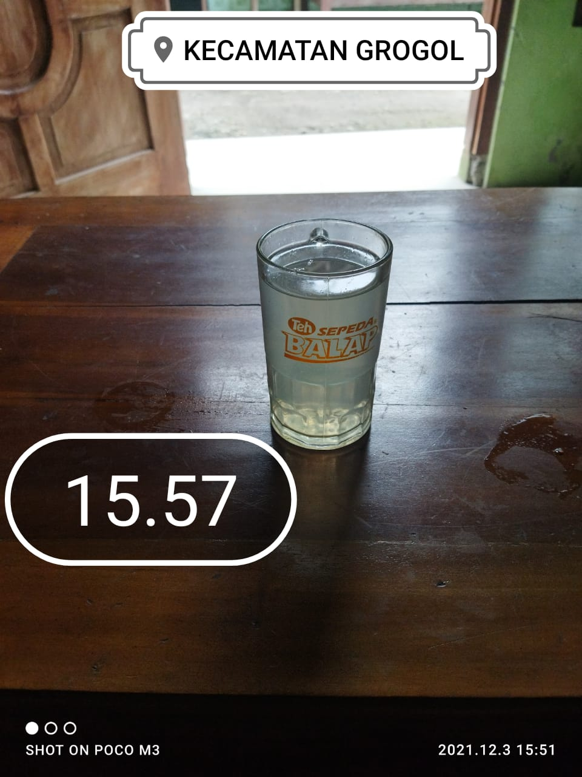
Source: A, photo diary studies, 3 December 2021.

Picture 6 shows a glass of warm honey and lime, as A takes care of her health while she looks after her ill child. L too gives supplements to her younger sibling for better nutrition (L, photo diary studies, 3 December 2021), A takes her mother to the clinic for monthly check up (At, photo diary studies, 4 December 2021), and A takes her husband to the hospital and waits for hours in line (A, photo diary studies, 4 December 2021). Health management for the family is done by Muslimah labourers, and they are aware that this is unfair. “When my father and older siblings were sick, I was burdened. I am the only woman. … From taking them to the doctor taking care of administration and everything” (L, hybrid group interview, 28 November 2021).

Here, we return to the sakinah family as common sense. Taking care of the family, buying herbal medicine, giving supplements to manage family nutrition, are the everyday, micro politics practices by Muslimah labourers as they take responsibility from the state and businesses (Wakefield and Flemming, 2019) for not only their wellbeing but also the wellbeing of others in their direct and extended family. They link this lived experience with promises of the afterlife.

“Well caring for parents is exhausting but there is a benefit [faedah], God willing [insha Allah] in the afterlife. There is definitely a benefit of taking care of parents today” (L, hybrid group interview, 28 November 2021).

“These make me happy. I turn them into a happy thing so that it has value as worship [ibadah], so that things that are exhausting, enjoy it so I am not tired (A, hybrid group interview, 28 November 2021).

Our research finds that the grievances of Muslimah labourers are material, but the way they are addressed are Islamic. The nature of their working and living conditions is insecure, and they take on household chores as well as care for and plan for the whole family. Whether in Solo Raya, Jakarta, or Indonesia, the Muslimah labourers part of our research hold a dual function in public and domestic spaces (Rakhmani, 2019); and do so piously. The locality of Solo Raya, for Muslimah labourers, while historically specific, are overshadowed by the fact that most, if not all, working class women cannot afford outsourced care work. If they do not take on domestic responsibilities, no one will do it. So it is less a form of reverence to patriarchy, than it is about the state’s incapacity to acknowledge their unpaid work; or provide a social safety net that takes that role away from them.

We also find that the ummah imagined, whether by the state and/or businesses, as part of the halal economy largely excludes Muslimah labourers. The circulation of halal goods and services, despite them comprising almost 17 percent of the total labour force (Annur, 2021), do not reach their social contexts. The consumption practices of Muslimah labourers involve predominantly the kinds of Islamic values that help them survive socio-economic marginalisation. The notional sakinah family is both an ideal they strive towards and a practical solution for the problem that taking on unpaid work is inevitable. Here, the calling of prayers five times a day, visiting the mosque at the end of a working day, gathering in the yard of the mosque–functions to organise and govern the domestic and public roles Muslimah labourers play. And, thus, their everyday experiences are observable micro settings in which Islamic morality are, by practice, introduced into the neoliberal capitalist structures they, and we, live in.

Conclusion

This article deals with rising Islamic piety as a response towards neoliberal restructuring in Indonesia. We depart from the assumption that neoliberal capitalism is hegemonic (though Gramsci reminds us that hegemony is never fully achieved and is inherently contested), and individuals and groups deploy Islamic values as a means to survive within this hegemony. We acknowledge that the body of work about this is overwhelmingly focused on the middle class in metropolitan areas, ignoring other social groups, namely women and working classes in middle-sized cities. With that in mind, we took the case of Muslimah labourers in Solo Raya, a locality under specific historical conditions of being the century of radical Islamists activities.

But our research finds that despite that local specificity, Islamist class movements are much less powerful that the workings of neoliberal economic structures; let alone claiming that we are seeing an Islamisation of the economy. The kinds of sharia economy imagined by Muslim bureaucrats, activists, and businesses respond to rising middle class aspirations, including those held by working classes. This, in turn, connects Islamic values with market practices. Therefore, consumption practices are micro-politics: working and middle class Muslims try to survive an increasingly insecure social world by ensuring that they are able to introduce Islamic values–that help guide their responses to neoliberalism–into the capitalist economy.

The everyday decisions Muslimah labourers make are located within a discursive tension between Islamic morality and neoliberal ideology, in a context where unionism has been far from effective. In many instances, this tension results in the reproduction of the notional sakinah family–where women play the dual roles of caregiver and worker. But we are not quick to assume that working class Muslim women are obedient to authoritative male Muslims. Based on what they have shared to us, the double burden is taken on because they know the government is not providing the kinds of social and health care they deserve; and thus they take on that responsibility. This, we think, is learned through their social position as labourers who are either part of a union or interact with those who are. Hence, for us, the pious ways with which Muslimah labourers manage the household is partly a response to the failures of the broader-based labour movement to pressure the state to provide social and health security.

And, consistent with this, the Muslimah labourers will again be disappointed by the way sharia economics–whatever we call it–is developed by state actors without paying attention to the interests of the working people and the poor. The resources allocated by the Indonesian government to build and strengthen the country’s Islamic financial ecosystem largely and fundamentally excludes the working classes of the ummah. When, in fact, the way Muslimah labourers modify and fill in the absence of social and health security with micro politics–using Islamic rituals as cues to self-organise–offers an “Islam as practice” rather than “Islam as doctrine”. However, this is useful only as we are aware that it inevitably works within an unfair, if not exploitative, neoliberal capitalist system. We too are aware that unless the state handles the kinds of unpaid work Muslimah labourers do, they are left without a choice other than taking on the load to care for those who are ignored by the social and health care system. To aid them in doing it, they reframe caregiving as Islamic worship (ibadah) and re-interpret unpaid work as being incentivised in the afterlife.

Returning to Gramsci, this is the sakinah family common sense that works for Muslimah labourers but, of course, fundamentally benefits capitalist transformations. It provides practical knowledge for Muslimah labourers in dealing with their socio-economic marginalisation, and helps them understand their position in the world. It is a practice that is shaped within struggles over capitalist hegemony, and, as mentioned, it is “fragmentary, incoherent, and inconsequential” (Gramsci, 1971: 419). And while it impinges on the collective wills of the workers to challenge the neoliberal structures that underpin their precarity and to emancipate themselves, it is no less meaningful in the everyday life of surviving an unfair socio-economic world.

References

Annur, C.M. (2021). “Mayoritas Penduduk Indonesia Bekerja sebagai Buruh pada February 2021”. Katadata. Accessed 1 October 2022 from https://databoks.katadata.co.id/datapublish/2021/08/11/mayoritas-penduduk-indonesia-bekerja-sebagai-buruh-pada-februari-2021
Bourdieu, P. (1977). Outline of a Theory of Practice. Trans. Richard Nice. London: Cambridge University Press.
Brenner, S. (1999). “On the Public Intimacy of the New Order: Images of Women in the Popular Indonesian Print Media”. Indonesia, 67, pp. 13-37.

Cakti, A. & A. Kurmala. “Indonesia’s halal export potential reaches US$3.6 billion”, Antara, 03 February 2022. 2022.https://en.antaranews.com/news/213117/indonesias-halal-export-potential-reaches-us36-billion

Cravets, O. and O. Sandikci. (2014). “Competently Ordinary: New Middle Class Consumers in the Emerging Markets”. Journal of Marketing, 125(78), pp. 125–140

Crehan, Kate (2016). Gramsci's Common Sense. Durham and London: Duke University Press.

Damayanti, I. (2021). “Erick Thohir Sabet Penghargaan Penggerak Ekonomi Syariah dari MUI”, Republika, 11 December 2021. https://www.republika.co.id/berita/r3xtl1349/erick-thohir-sabet-penghargaan-penggerak-ekonomi-syariah-dari-mui
Dickstein, J., J. Dutkiewicz, J. Guha-Majumdar & D. R. Winter. (2020). "Veganism as left praxis". Capitalism Nature Socialism (2020): 1-20.
Filippini, Michele. (2016). Using Gramsci: A New Approach. London: Pluto Press.
Ford, M. and L. Parker. (2008). Women and Work in Indonesia. London: Routledge.
Ford, M., Piper, N. (2007). Southern Sites of Female Agency: Informal Regimes and Female Migrant Labour Resistance in East and Southeast Asia. In Hobson, John M. and Seabrooke, Leonard (Eds.), Everyday Politics of the World Economy, (pp. 63-79). Cambridge: Cambridge University Press.
Gramsci, A. (1976). Selections from the prison Notebooks. (Ed.). Hoare, Q. London , England: Lawrence and Wishart.

Hadiz, V. R. (1997). Workers and the State in New Order Indonesia. London: Routledge.

Hadiz, V. R. (2016). Islamic Populism in Indonesia and the Middle East. Cambridge: Cambridge University Press.

Hadiz, V. R. (2011). “Indonesian Political Islam: Capitalist Development and the Legacies of the Cold War.” Journal of Current Southeast Asian Affairs, 30:1, 3-38.

Harvey, D. (2005). A Brief History of Neoliberalism. London: Oxford University Press.

Haryani, R & K. Dombroski. (2022). "Producing Economies of Care in Yogyakarta”. In C.S. Hossein & Christabell P.J. (Eds.) Community Economies in the Global South: Case Studies of Rotating Savings and Credit Associations and Economic Cooperation; pp. 167-186..

Hasyim, S. (2019). “The Political Economy of Sharia and the Future Trajectory of Democracy in Indonesia”, ISEAS Perspective, No. 2019/108.
Juliawan, B. H. (2011). ‘Street-Level Politics: Labour Protests in Post-Authoritarian Indonesia’. Journal of Contemporary Asia, 41:3, 349–70.
Krier, E. S. (2011). “Our roots, our strength: The jamu industry, women’s health and Islam in contemporary Indonesia”. PhD thesis. Pennsylvania: University of Pittsburgh.
La Botz, D. (2001). Made in Indonesia: Indonesian Workers Since Suharto. Cambridge: South End Press.
Mahdi, O. (2014). “From Islamic Radicalism to Islamic Capitalism: The Promises and Predicaments of Turkish-Islamic Entrepreneurship in a Capitalist System: The Case of IGIAD”, Middle Eastern Studies, 50:1, 144-161.
Mahmoud, S. (2011). Politics of Piety: The Islamic Revival and the Feminist Subject. Princeton: Princeton University Press.
Muhani, W.K., W.M.H.W. Hussain, N. I. Ya’akub, I. Kasri, & E. A. Rozali. (2012). “The political and economic contributions of the Muslim middle class in Malaysia”, Advances in Natural and Applied Sciences, 6:3, 285-295.
Naafs, S. (2012). “Navigating School to Work Transitions in an Indonesian Industrial Town: Young Women in Cilegon.” The Asia Pacific Journal of Anthropology 13:1, 49–63.
Nasr, S. V. (2009). Forces of fortune: The rise of the new Muslim middle class and what it will mean for our world. London: Simon and Schuster.
Oxfam. (2017). Towards a More Equal Indonesia. Jakarta: Oxfam.
Parfitt, C. & T. Barnes. (2020). "Rethinking economic security in a precarious world." Critical Sociology, 46.4-5; pp. 487-494.
Primadytha, S. (2022). “BPJS Watch Kritik Pekerja Kontrak Sulit Akses JKP”. CNN Indonesia. Accessed 30 September 2022 from : https://www.cnnindonesia.com/ekonomi/20220215143822-78-759436/bpjs-watch-kritik-pekerja-kontrak-sulit-akses-jkp
Rahman, F.N. (1996), ‘A feminist theologian on women, Islam and feminism’, Women’s
Own Karachi, Riaz Ahmed Mansuri, August, pp. 91–3.
Rakhmani, I., Utomo, A., Phillips, C., & Setyonaluri, D. (2020, March 30). COVID-19, women and digitised food networks in Jakarta: Inequality and resilience. Retrieved from Melbourne Asia Review: https://melbourneasiareview.edu.au/covid-19-women-and-digitised-food-networks-in-jakarta-inequality-and-resilience/
Rakhmani, I. (2019). The personal is political: Gendered morality in Indonesia's Halal consumerism. TRaNS: Trans-Regional and-National Studies of Southeast Asia, 7(2), 291-312.
Rakhmani, I. (2016). Mainstreaming Islam in Indonesia: Television, Identity, and the Middle Class. USA: Palgrave MacMillan.
Rosser, A and Van Diermen, M. (2016). Predation, productivism, and progressiveness: the political economy of welfare capitalism in post-new order Indonesia. In: Lim H, Hwang S and Pieterse J (eds) Capitalism and Capitalisms in Asia. Seoul, South Korea: Seoul University Press, pp.301–331.
Sakai, M and Fauzia, A. (2016). “Performing Muslim Womanhood: Muslim Business Women Moderating Islamic Practices in Contemporary Indonesia”, Islam and Christian–Muslim Relations, 27:3, 229-249
Sandercock, L., & Attili, G. (2010). Digital ethnography as planning praxis: An experiment with film as social research, community engagement and policy dialogue. Planning Theory & Practice, 11(1), 23-45.
Syechbubakr, A.S. (2020). “Can the omnibus law do what its drafters claim, and bring investment and jobs to Indonesia?”. Indonesia at Melbourne. Accessed 20 September 2022 from: https://indonesiaatmelbourne.unimelb.edu.au/can-the-omnibus-law-do-what-its-drafters-claim-and-bring-investment-and-jobs-to-indonesia/
Phillips, L. and U. Plesner. (2013). Researching Virtual Worlds: Methodologies for Studying Emergent Practices. London and New York: Routledge.
Sandikci, O., & Rice, G. (2011). Handbook of Islamic Marketing. Cheltenham & Northampton: Edward Elgar Publishing.
Sen, K. (2002). Indonesian women at work: Reframing the subject. In K. Sen and Maila Stivens. Gender and power in affluent Asia (pp. 49-76). London & New York: Routledge.
Suryakusuma, J. (2011 [1988]), State Ibuism. The Social Construction of Womanhood in
New Order Indonesia. Jakarta: Komunitas Bambu.
Syifa, M. (2022). “Perkembangan sektor kosmetik halal di Indonesia”. Kumparan. Accessed 1 October 2022 from: https://kumparan.com/mutiarasyifa2809/perkembangan-sektor-kosmetik-industri-halal-di-indonesia-1xkhD6HFIf4
Utomo, A. J. (2012). “Women as Secondary Earners: Gendered Preferences on Marriage and
Employment of University Students in Modern Indonesia.” Asian Population Studies
8:1, 65–85.
Wakefield, A and Fleming, J. (2009). Responsibilization. Thousand Oaks, CA: Sage.
Wieringa, S. E. (2015). “Gender Harmony and the Happy Family: Islam, Gender and
Sexuality in Post-Reformasi Indonesia”, South East Asia Research, 23:1, 27-44
Wills, J. (2014). “The World Turned Upside Down? Neo-Liberalism, Socioeconomic Rights, and Hegemony”, Leiden Journal of International Law, 27, 11-35.
Yasih, DWP. (2023). “Normalizing and Resisting the New Precarity: A Case Study of the Indonesian Gig Economy.” Critical Sociology. 49(4-5), 847-863.
Yasih, DWP and Hadiz, V.R. (2023). “Precarity and Islamism in Indonesia: the Contradictions of Neoliberalism.” Critical Asian Studies. 55:1, 83-104.
Yasmin, N. (2021). “Digitalization big opportunity for sharia economy: Amin”, Voice of Indonesia, 03 December 2021. https://voinews.id/index.php/international-news/item/16798-digitalization-big-opportunity-for-sharia-economy-amin

The research for article was funded by Directorate of Research and Development, Universitas Indonesia under Hibah PUTI 2023 (Grant No. NKB-346/UN2.RST/HKP.05.00/2023) in collaboration with Vedi R. Hadiz. The authors thank Hari Nugroho, Andi Rahman Alamsyah, Benni Setiawan, Panji Anugrah, Nur Rafiza Putri and all the women labourers who spent time and energy to reflect on their position in the current social world. An earlier draft of this article was presented at the ISEAS-Yusof Ishak Institute Workshop, “Emerging Muslim Lifestyles in Maritime Southeast Asia: Impact on Multicultural Societies”, held on 7 and 8 November 2022.
The term ‘radical’ is given to those who demonstrate rigid adherence to the idea of an Islamic state and resentment toward the process of democracy.
Historically, the growth of the working class in the region was triggered by its development as a site of light manufacturing production during the period of rapid industrialisation under the New Order. The consolidation of political Islam in the region itself can be traced back to the organisation of the pious Muslim traders, who played a central role in the anti-colonial struggles in the early twentieth century.
This is only allowed for a maximum period of two years and only extendable for a year (Manpower Law No. 13/2003).
In 2003, the implementation of Manpower Law, led to the widespread practice of contract labour and outsourcing. In 2020, at the height of Covid-19 pandemic, the enactment of the Job Creation Law led to workers facing a more difficult and uncertain labour market (Yasih, 2022).
Indonesia’s social welfare system remains largely underdeveloped, though some improvements were made in the system after the 1997-1998 crisis (Rosser and Van Diermen, 2016).
The Muslimah labourers acknowledge a general absence of effective unionism. A Muslimah labourer states “even with a union, the welfare of employees are not [guaranteed]. Imagine without a union” (N, hybrid group interview, 28 February 2022). In theory, unions could help working people push for substantial concessions from state and capital. But in Indonesia, labour and broader society movements were heavily repressed under the New Order authoritarian regime (Hadiz, 1997). While the end of authoritarianism presented new opportunities for unions to consolidate their forces, they are struggling to remain relevant, especially after decades of repression under the New Order (Juliawan, 2011). Most unions' activities have been directed mostly at regulatory reform, fitting with the workings of neoliberal professionalism, while inadvertently promoting animosity towards notions of class struggle (Yasih and Hadiz, forthcoming).
A Muslimah labourer mentions “I dream of returning to school… now I have income” [A, hybrid group interview, 28 November 2021]). Another Muslimah labourer explains how she raises goats for profit, as a way of saving money, needed to send her sons to Islamic boarding schools (N, hybrid group interview, 19 December 2021)

